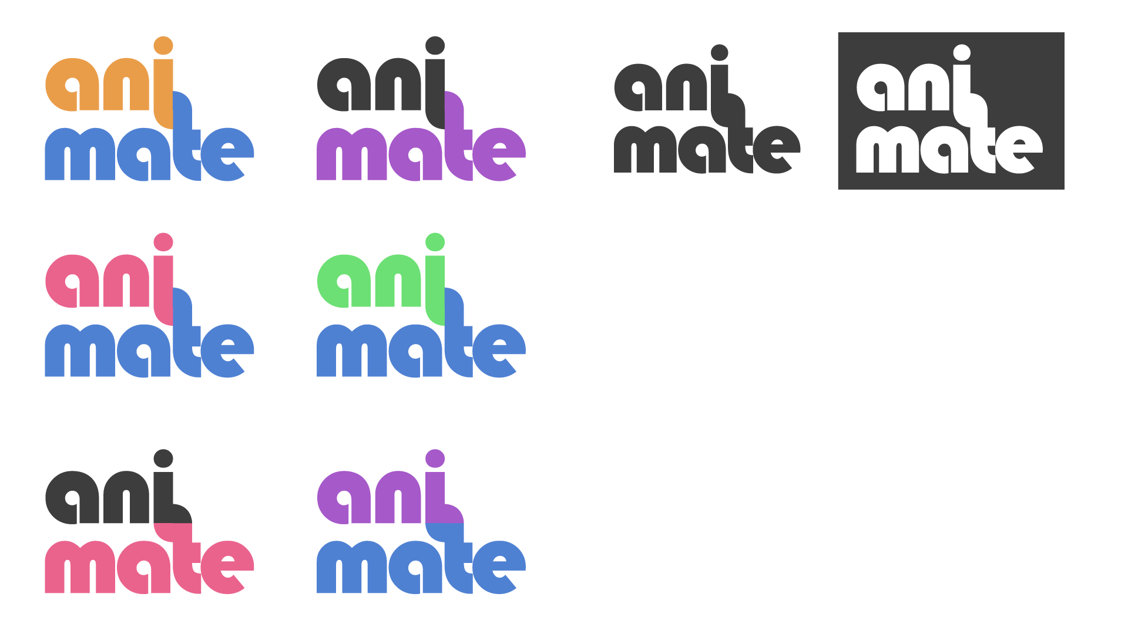

|  |  |
| --- | --- |
| Major Project COM559  Interactive Multimedia Design | Student: Jack Penton B00662595  Mentor: Jonathan Wallace Group: 6 Year: 4 |

# Acknowledgements

I want to take the time to say thanks to all the people who have helped me throughout up to this point in the project. To my mentor Jonathan for his advice on what else I should implement in my reports’ deliverables in order to maximize its potential, insights on how to present my prototype for the deadline in January to best show the functionality of the feature.

I also want to thank the teachers of all the modules in the IMD course whose lectures have helped contribute towards the knowledge needed in order to partake onto a development such as this, thanks to George Moore whose slides and advice on what is expected throughout has definitely been of great help.

Table of Contents

**Acknowledgements1**

**Contents1 - 2**

**Introduction3**

Aim & Objectives3

Scope3

Overview of Work Undertaken4

Overview Report4

**Concept Definition and Testing5**

Idea Generation & Contextual Research5

Requirements Specification6

Feasibility Testing9

Methodology Selection10

Risks10

**Design16**

Workflow16

6’s & 1’s17

Logo & Branding20

Artboard21

**Implementation22**

Client Model View22

Client Side Technologies23

Server Side Technologies25

Developer Tools25

ER Diagram26

System Flow Diagram26

**TestingNA**

**EvaluationNA**

**ConclusionNA**

**References27**

**Appendices28**

Introduction

A website in browser that allows you to select pre-made CSS3 Animation sets and watch a live preview play out in real time, along with dispensing the code that make the animation so as the user can copy it for their own use.

The ability to also change certain specifics of the animation such as time-delay and rotation to allow more customizability for each user’s needs.

There is a lot in current websites that you can get a preview of the animation that will happen but in order to use that animation or customize it you have first got to download the source file and finally link it in your code in order to use it, whereas the idea addressed here allows you to detail your own animation from the one given and immediately take that code.

Aim

The aim is to deliver a fully functional web-based Animation Previewer that accomplishes the necessary criteria and more of what has been set out to complete along with being a viable asset to modern front-end developers / designers within todays industry.

Objectives

* Meeting project / module deadlines before they are due.
* 22 hours per week working and developing upon the project.
* Create a Gantt chart to help manage time.
* Create the product to be cross-platform for PC, Tablet and Mobile.
* Create a range of simple animations.
* Finish a prototype by December.
* Develop the platform to have high accessibility.
* Create a database to help store user logins.
* Make a style tile and wireframe for initial design concepts of page layout and theme.

Scope

The Animation Previewer **should** include the following features:

A user sign-up and login in order to meet the assignments deliverables, a range of animations to be available and inputted into the selection of animations to choose from, an intuitive interface that allows for ease of use and high accessibility in order to broaden the audience and meet global website accessibility guidelines, the ability to download the selected animation for future use, a real-time preview of the animation selected, code made available to immediately copy to your clipboard for each animation and lastly sliders (or another type of input) in order to allow user customizability to the animation.

Features that **should not** be included as part of this project are as follows:

User profiles and account details pages as they are not part of the design structure and would only interfere with the service trying to be provided, payment gates or form of payment of any kind as it would be against general ethics in the creating of something intended to be helpful to the users in today’s industry and lastly advertisements as they are everyone’s detested web element.

Overview of Work Undertaken

To develop the “AniMate” project, a structured approach was needed in order to ensure the best possible outcome and learn best practices. Research into other similar products, tools, possibilities and requirements needed to be carried out, structured time-lined plan to adhere to, development and testing.

Overview of Report

As you will see in the following report, you will see a structured approach to development written out from things such as Background Research, Gantt Chart, Development Methodologies, UX and System Design and testing. All these together are laid out in a professional way to ensure the best flow.

Concept Definition and Testing

Idea Generation & Contextual Research

Back in the early 2000’s animations and interactivity in websites were accomplished by using Adobe Flash Player which was widely used but has steadily declined ever since with more modern, optimized ways of getting the job done such as CSS3 Animations, Animated SVG’s, JavaScript, JQuery which has basically taken over the scene.

*“The post-Flash era is hardly free of animation. CSS animation is quickly becoming a cornerstone of user-friendly interfaces on mobile and desktop, and JavaScript libraries already exist to handle complex interactive animations.”*

* Rachel Nabors (Smashing Magazine)

In the World Wide Web the amount of progress happening on a constant basis is huge, with many new job titles being created in the process such as people specializing in Back-end, Front-end, Animation, Designer and UX Designers.

The part that will be focused on is the animation side of the web which has solidly ingrained itself within the industry that when used right, adds huge flair, creativity and can help distinguish you from the others.

*“Today animation became ingrained in web design and seems to be a great addition to many website elements.”*

* Julia Blake (Line 27)

So as animation with its uses and daily integrations growing every day, so have the number of open-source creative animation sets appearing on the web, usually accompanied by their own personalized homepage that lets you preview the sets they have to offer. Some examples of this would be Animate.css, Minimamente and ***Hover.css*** to only name a few, particularly with ***Animate.css*** and ***Minimamente*** of which are more in line with the direction of the idea presented in this report. You select / click on one of the animations and you will see it play out in real-time but that is it, no code to immediately use the animation you have selected, no download for only that snippet, you have to download the entire library in order to use it which in turn increases the overall file size of your website and therefore your website loading speed decreases.

Now sometimes it is ideal to have a whole stylesheet to work with at first, but the idea behind this project is to offer more flexibility to the whole fiasco of downloading the source, linking the stylesheet to your website, removing the unnecessary bloat from that stylesheet so on and so forth, whereas if the student can accomplish what he set out to do, designers & front-end developers can select an animation, specify its characteristics, copy that snippet of code into their clipboard and input it directly into the **one** stylesheet that they are already using.

The closest thing found that is along the same lines that this project is going for are things such as the box-shadow generator at ***cssmatic.com/box-shadow,*** it gives a preview of the result, sliders to customize the characteristics, and the code snippet output for you to directly use. It isn’t an animation previewer but it gives a good idea of the kind of traits being sought for to incorporate into the project.

Requirements Specification

Outlining the requirements for your project can be seen as quite the mountain to climb, but thanks to Volere and their requirement template which gives you a structured way to gather information, lay it out neatly and see what requirement effects the other which is done by using their Snow-Cards.

The Volere Method a long standing method that has been tried and tested throughout the years and is still broadly used by companies today.

The Snow-Cards as said above allow you to efficiently document your requirement data by separating your information into the following parts:

**Requirement Number (#):** The ID number of the requirement

**Requirement Type:** Whether the requirement is functional or non-functional

**Use Cases (#):** 0Other ID’s which require this requirement

**Description:** Brief description of the requirement

**Rationale:** The reason as to why it is required

**Fit Criterion:** How the requirement is tested

**Customer Satisfaction:** The satisfaction the customer will have if requirement is complete

**Priority:** High, Medium or Low status

**Conflicts (#):** Other ID’s that have to be made in order to make this requirement

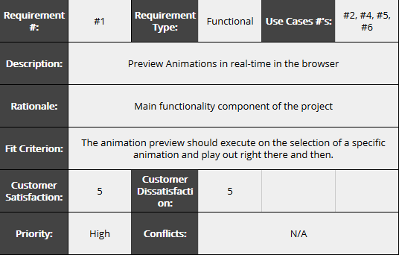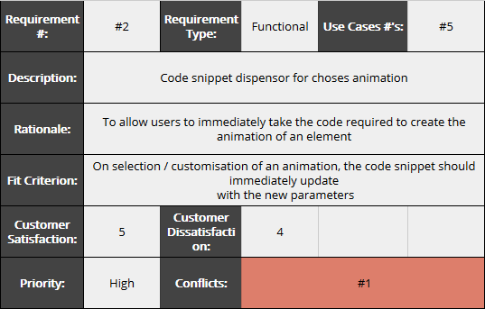

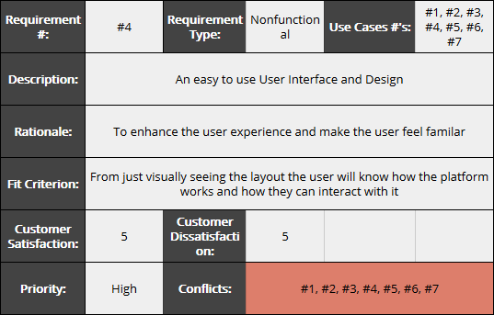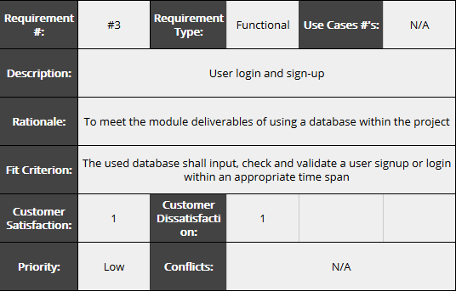

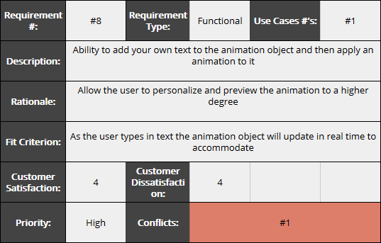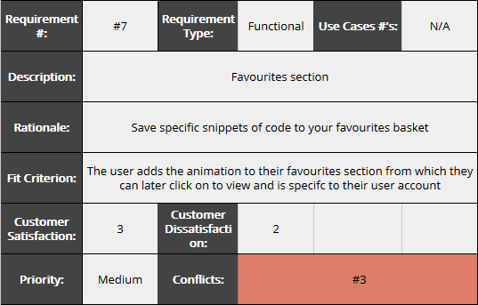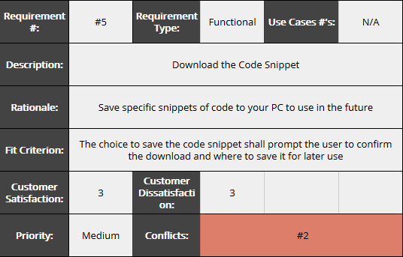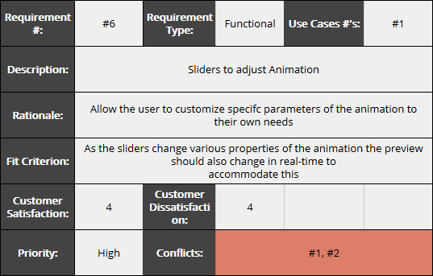

The above are the Snow-Cards that have been gathered throughout the research cycle.

A link to the google spreadsheet can be found here:

https://docs.google.com/spreadsheets/d/1EgBQvQQFBBxtbCmb_2unC1ByYzWbZKo52KGK2Jpfy-I/edit?usp=sharing

Feasibility Testing

In order to test the feasibility of the project a prototype is needed to be developed. It will tackle one of the highest risks that presents itself towards the project and therefore help to further progress the ease of development of future features.

From looking through the projects list of risks and variables, it was decided that the highest risk of the project was the use of range sliders alongside JavaScript to change animation duration and the animated objects characteristics in real time and then play out those updated inputs. The plan was to develop a prototype that represents this problem and shows the solution to solve it whilst being laid out in a professional way to best present the situation. Another reason this feature is being completed first is due to the fact that multiple other functions also rely on this such as:

1. Code Dispenser to give the code for the updated animation
2. Favorites basket for user saved animations

Risks

|  |  |  |  |
| --- | --- | --- | --- |
| Name of Risk | Impact on Project | Probability of Occurrence | Solution |
| Animation Preview in Real-Time | This is the core feature of the project and thus without it, would fail the module. | High | Since this is core functionality, it will be the first to be challenged once a webpage has been made and therefore will receive the most care and attention to detail, mitigating the likelihood of it being a proceeding problem. |
| Code Dispenser | Core feature to the final product of this project, with its intended use being quite integral to what is trying to be accomplished. It also depends on whether “Animation Preview in Real-Time” can be achieved. | High | Allotted sufficient amount of time to research the problem and has been placed alongside at about halfway with the first risk in the development process. |
| User Login and Signup | Needed to meet Major Project deliverables for the SQL Database. | Low | Since previous knowledge on how to accomplish this has been acquired, implementation should not be a problem. |
| User Interface and Design | Large amount of time needed to wireframe and flesh out a design that is minimalistic and easy to use is quite high. | High | Design up and flesh out a webpage with the needed inputs and iterate constantly in little snippets throughout development in unison with the other risks to fully realize the best layout. |
| Code Snippet Download | An optional feature that allows for more flexibility and a more all-round experience. | Low | Tasked for near the end of the development process cycle, so if time is available it can be implemented. |
| Sliders to adjust Animation | If this feature is not made available, then the potential user base for the product is reduced. | High | Probably one of the most complex parts of the project but one that is surely doable if enough time is available for it. |
| User made text to be animated | Will probably have a noticeable impact as it gives users more customizability to their animations | Medium | Should be easy to going about implementing this with JQuery and the “input” event handler |
| Favorites Basket | Impact of this feature being left out is not that big as it is not a necessity | Low | Maybe look into Laravel or some PHP tutorials on how to go about this problem. |
| Knowledge of the unknown | Current technicalities to be implemented into the project of which the knowledge has not yet been acquired. | High | Keep up attendance to lectures, research techniques and such independently. |

Resources

The following resources **will** be needed:

* Database with MySQL – to store user login and signup details.
* Server hosting – to upload the project to the webserver for functionalities to work such as MySQL.
* Text Editor – to develop and iterate the project as a whole.
* Browser – to test, preview and use the product.
* Web Development languages (HTML5, CSS3, JavaScript, JQuery and MySQL).
* Computer – with an internet connection, and sufficient hardware.

Plan

There are many methodologies to use that have been thoroughly tried and tested which offer a range of different ways to go about developing a project depending on team size, time needed and type.

**Waterfall Method**

This method is suited to small projects and is straightforward in the sense that when you have your requirements and research nicely mapped out, you can proceed on down the steps of the process, just like a waterfall, completing each section until you reach the testing and deployment phase.

At this point you’ve went through each section, completed it and moved on and any problems that may occur are only found during the test period which makes it difficult, timely and costly to go back and iterate on what you have already made.

This methodology does not suit the needs of the current development process and therefore will not be used.

**Prototyping Method**

If time is not an issue the this methodology would probably be the direction to take, as it does not require you to have all your requirements readily defined and allows for constant iteration with each prototype by using whatever requirements you may have, design a prototype, develop it, review it and finally enhance.

With every cycle it allows you to see the project become more and more fleshed out.

The downside to the method is that even though it is well rounded, it takes more time and is more suited to larger team sizes. For these reasons this method will not be used as time is of the essence.

**Modified Waterfall Method**

This is the chosen method as it is the most beneficial for the project in how it operates:

Requirements Analysis

Code

Test

Deploy

Design

The Modified Waterfall Methodology is one that has been tried and tested, allows great manageability to the project at hand if requirements and research have been thought out properly, easy to use and well suited to individual practices.

This allows for a straightforward guide that allows constant iteration within each cycle to go back and change or improve upon certain aspects to the project while laying out the development process of which also has the advantage of being suitable for small individual projects.

A Gantt chart of the Time-Schedule will be aiming to coincide with is documented below:

It outlines the weeks for nearly every aspect of the first semester including the projects estimated timetable of development for each stage of the Modified Waterfall Methodology with further detail into the individual and the Hard & Soft Deadlines of the modules deliverables.

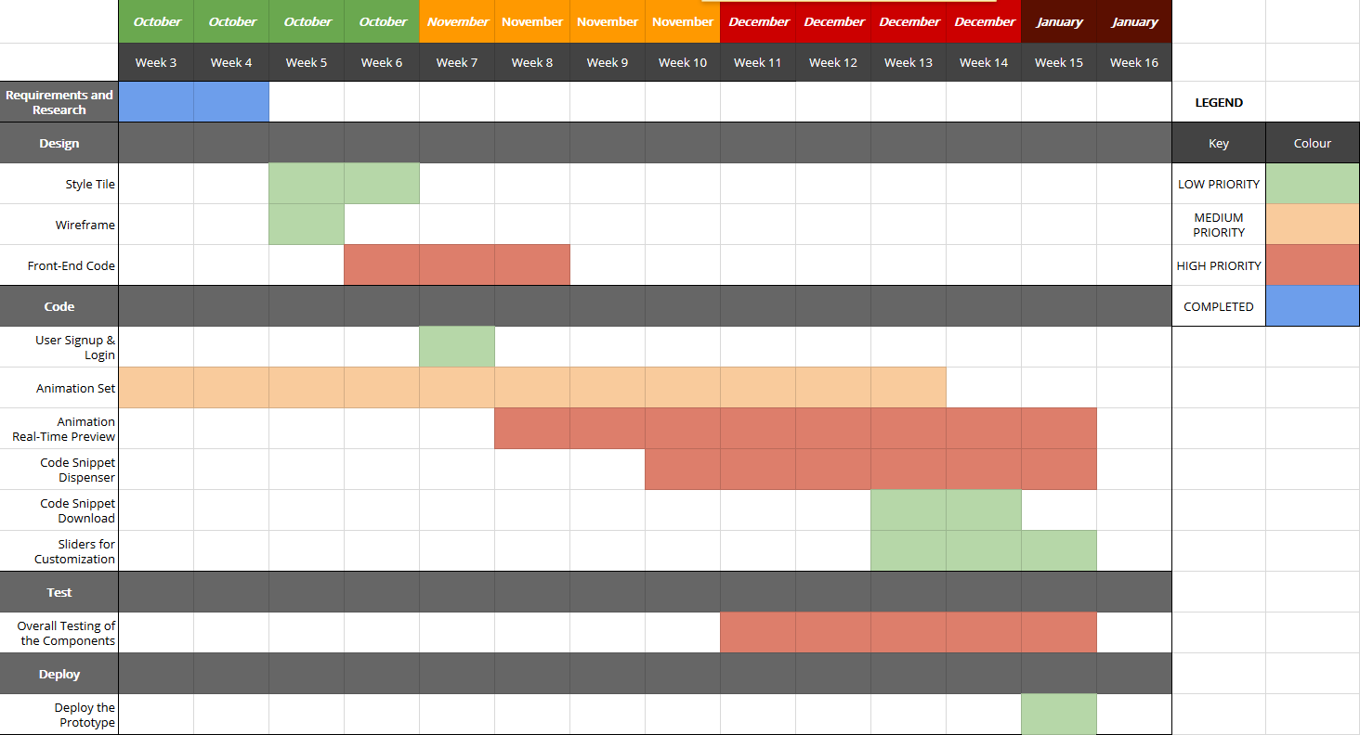

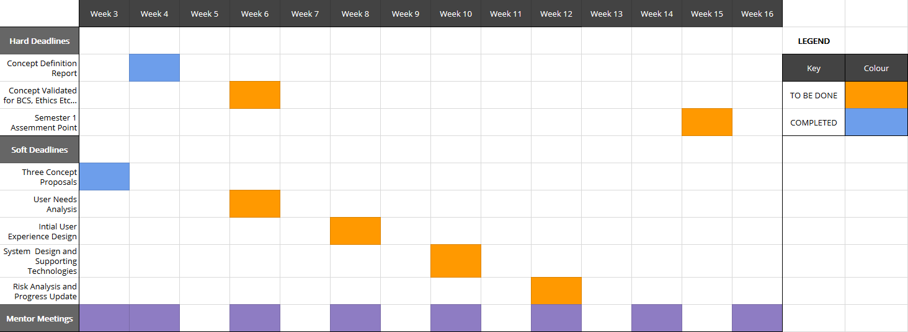

You can find the online version here:

https://docs.google.com/spreadsheets/d/1n8p2En7LdQRJOme7JWwX0zB9YSc9oVNN8GJP2v3LdWY/edit?usp=sharing

Design  
Workflow

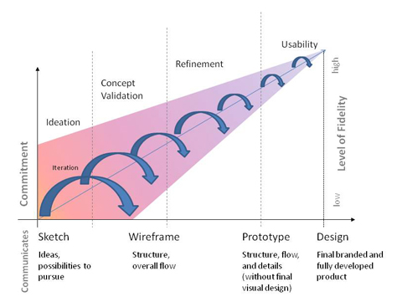Starting off for the design stage I need to decide on a workflow to coincide with my Modified Waterfall Method that has been chosen for development.

The figure on the right shows the structure of which the User Experience and Layout Design will be developed upon. **Commitment**, **Level of Fidelity** along with the different **Stages** (Sketch, Wireframe, Prototype and Design) must be kept in a balance as to allow for the optimal time efficiency, too much Commitment and Level of Fidelity should not be done in the first Stages as it will use up time better spent on the areas that need it. The project will be done as follows:

1. 6 & 1’s – Six Sketches will be drawn out each with their own separate layout of the elements needed on the page in order to narrow down the design to what is best, of which the seventh one will be more detailed and refined containing a more reliable and fitting UX and Design.
2. Prototype up the layout using an even greater Level of Fidelity.
3. Finalize the design and branding, code it up with HTML and CSS to get an actual visual on the intended project layout.
4. This process will then continue to develop alongside the Modified Waterfall Method and be re-iterated constantly as the project comes into being.

6 & 1’s – Main Page

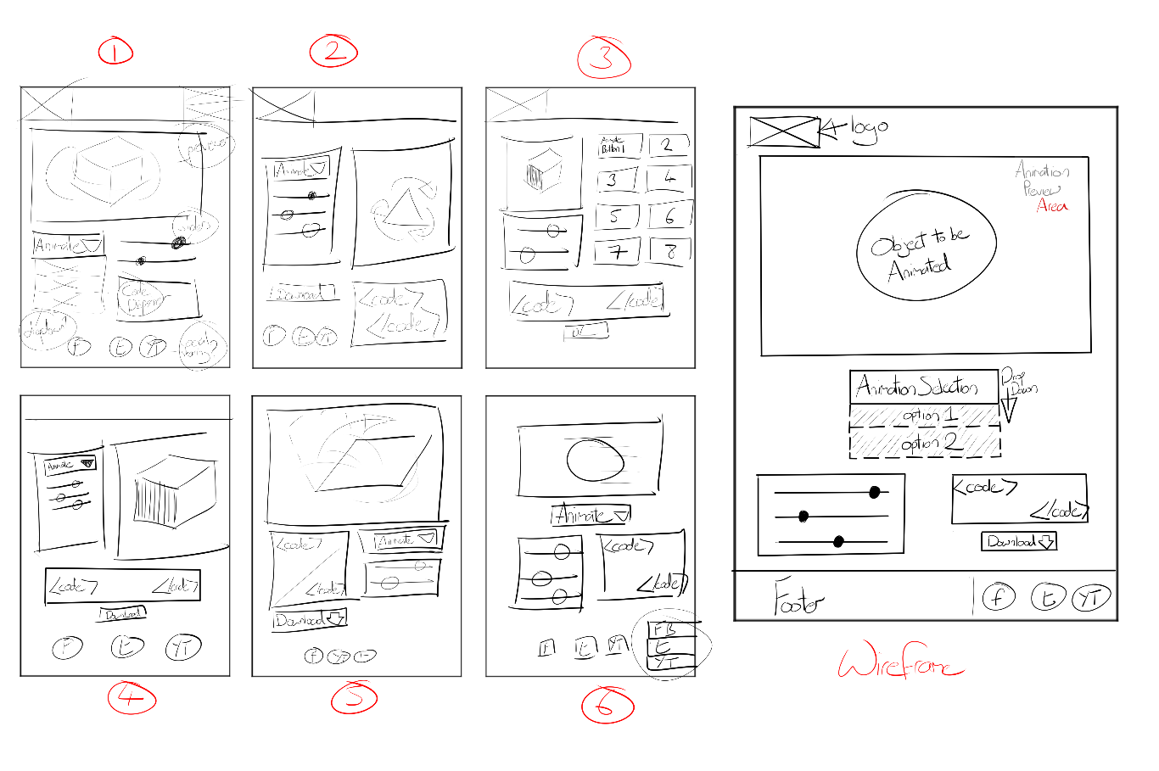

1. First sketch – has a header which would be used to house the logo image and a navigation to the site but was deemed unnecessary as there is not a strong need for multiple pages for this project and thus does not need to have a strong indicator to focus the user there. The main focal point is the Animation Previewer and how to operate it so having the two main elements for doing so just beneath helps to indicate to the user of its function and purpose. The code dispenser coming once again below the sliders to show the hierarchy of the elements.
2. Second Sketch – still contains the header, the sliders and animation selection has become an aside to the left of the Previewer perhaps allowing better ease of access to the controls and overall convenience in doing so. Code dispenser and the download for it come underneath but split into two parts. It starts to look a bit cluttered with more elements being put side by side and the feel for the product does not seem to resonate for this layout.
3. Third Sketch – taking into consideration some of the examples of real world uses for something along these lines, the layout was made with separate buttons which would trigger the Animation Preview on the left and the sliders to customize coming below that. The code dispenser is then made into full width to complete the design but overall this is not the style the project should go in, there is too much clutter and does not allow for much flexibility for future expansions to the choice of animation.
4. Fourth Sketch – joined up the animation selector and customizable sliders into one element in an aside similar to the second sketch, this time making the code dispenser full width and the download button below it in a smaller size creating an OK flow to the whole experience but it is not quite there yet.
5. Fifth Sketch – header is taken away in order to open up the white space a bit more and help to minimalize the layout a bit, the previewer is full width and is the first thing you see, below is the code dispenser followed by the animation selector and sliders. The positioning of the previewer is perfect but the other elements still do not have their placement quite right.
6. Sixth Sketch – there is now a more structured look to the way the elements are presented and an overall more minimal style. This is more in line with what is hoping to be achieved through this trial and error sketching process.
7. The Wireframe – I don’t include the header but I work the logo into the top left. The layout is taken from Sketch 6 and helps to define a hierarchy between the elements, the user will first see the previewer, then the animation selections followed by the sliders and code dispenser to create a triangle. The user can easily identify with what to do in order to operate the canvas and what specifically effects the other. The insertion of the footer is to possibly allow for some portfolio links and social media platforms, laid out in a clean compact way as to make its presence non-intrusive. Overall this is the along the lines in which the project is most suited, more iterations and polish will become apparent as development ensues.

6 & 1’s – Signup Page

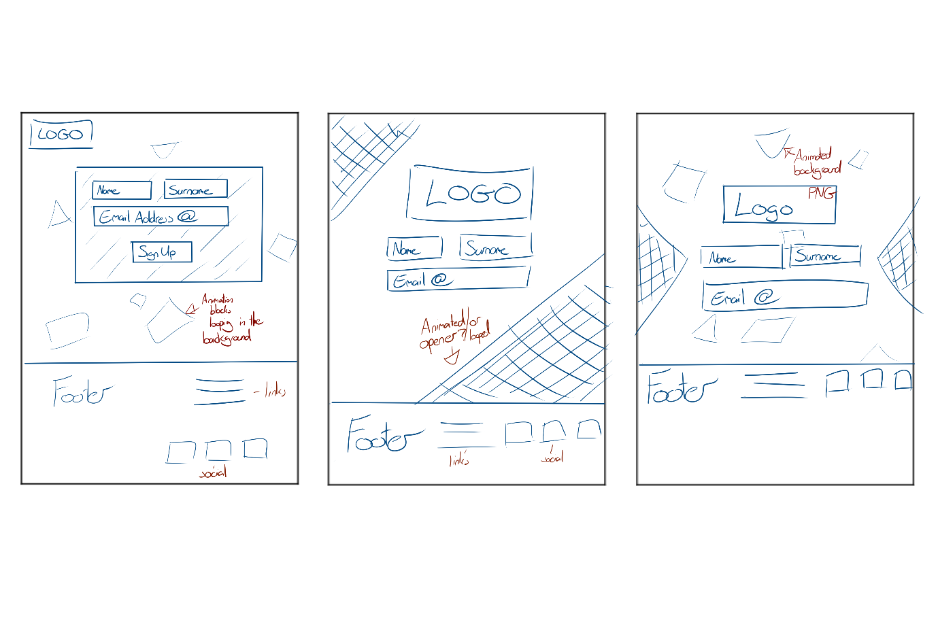

1. First Sketch – Simple setup with logo small situated at the top left of the page, whilst using a standard form layout inside a solid coloured box. There is an animated background looping on in the background which will help to give the user a sense of what this website is about and is going to offer them. The footer is standard with links and social media icons for shares.
2. Second Sketch – Trying to break away from the standard format of a signup page by enlarging the logo and placing it more predominately on the page, whilst opening up the form from a container and having diagonal shapes at each corner encapsulating the center page to draw more attention. The footer is laid out more inline this time to help compact and minimalize.
3. Third Sketch – The last sketch is one of a mix between the first two, taking on the enlarged logo, open form, triangles at the sides vaguely indicating towards the center page, animated background of floating shapes and the inline footer from the Second Sketch.

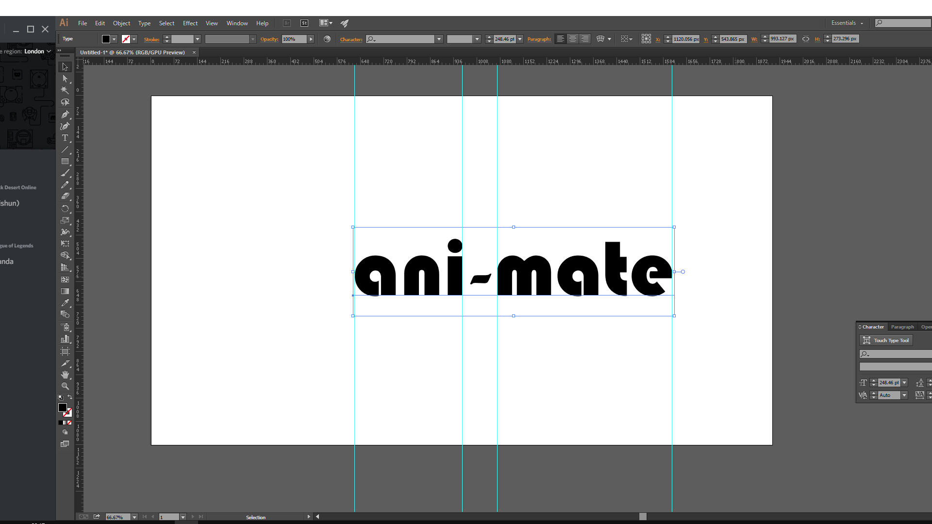Logo & Branding

In order to further personalize and brand the project that is being made, it’s also in need of some character in order to define itself.

This is where the logo and branding come in. After going through a range of fonts for the logo, ultimately **Bauhaus 93** was chosen, which is a nice simple, clean geometric styled font that best suited the style and theme planned for the project.  
Two colours were also used as placeholder in order to help separate and distinguish the two parts of the logo name.

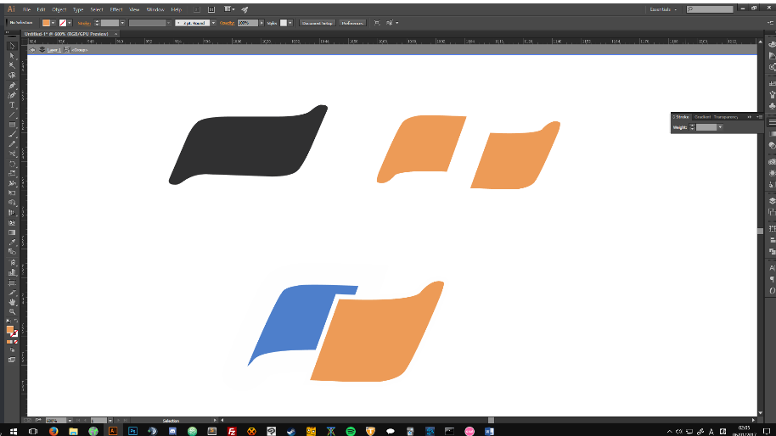

Here was the first edition in the development of the logo brand, it started with playing around with two different colours to separate the word “animate” and using a hyphen to create a kind of trademark that could be a part of the actual logo name itself.

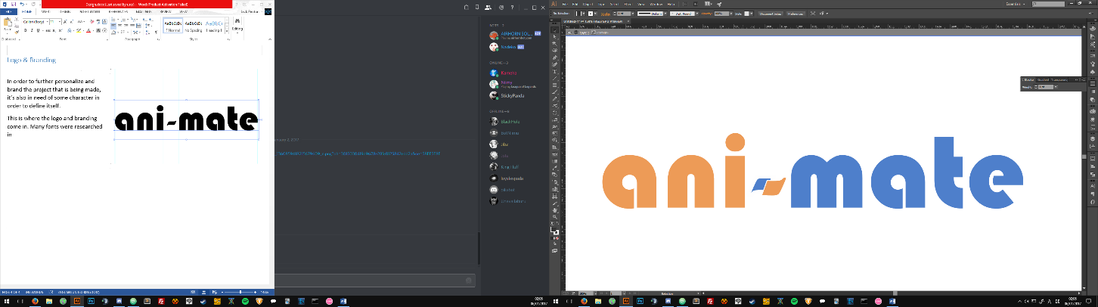Overall it didn’t really feel fit the theme for what was trying to be accomplished for the feel and flow of the project.

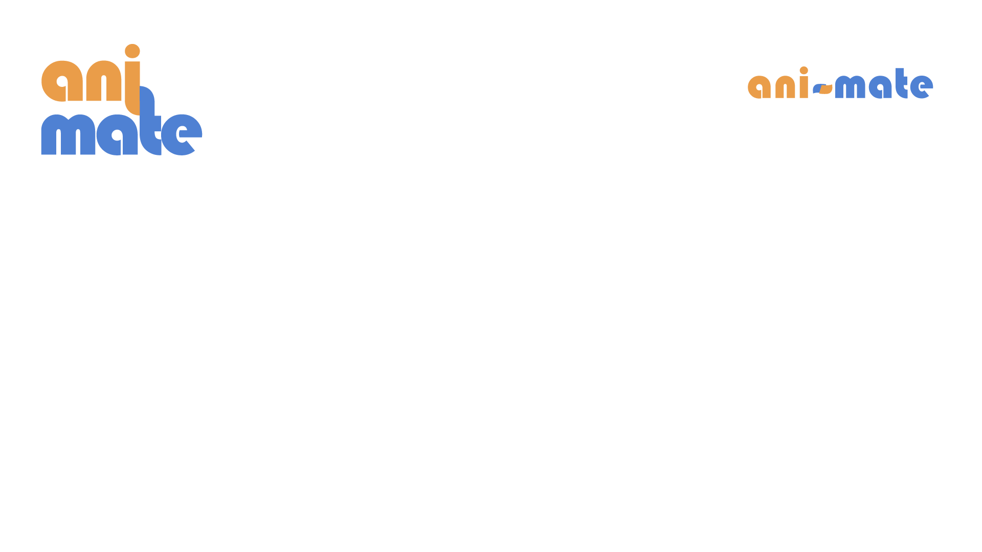The second edition that was made felt a whole lot better in terms of what is being sought for within the logo design. Something simple, easily recognizable with a bit of a quirk to tie the two together. The compactness done via reducing the tracking between the characters also serves to enhance the logo.

Artboards



Above is an artboard drafting different colour combinations that may work with the logo along with doing some tweaks as you can see on the last two in order to check out another angle.

System Design

Now that the system design has been detailed out and completed the next step in the development of Ani-Mate is the System Design of how each component will function within the overall project.

Client Server Model

The Client Server Model is a renowned and popular model that is easy to understand of which is only one in an array of perspectives that can be used to show and layout the starting point for identifying technologies that will be used in a project.

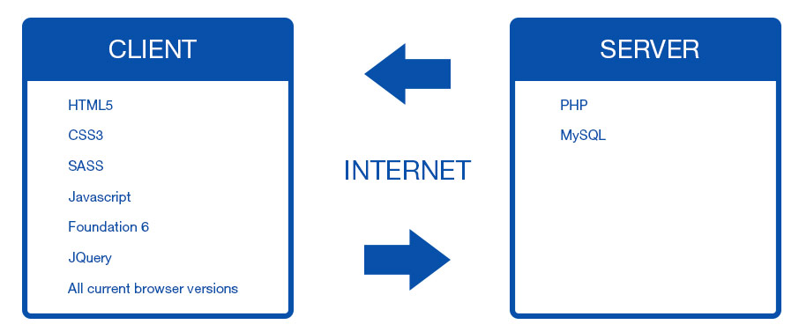This model is structured in way that shows you all the technologies that will be processed on the user’s client-side and what technologies will require the internet in order to process information stored on the server-side.

Technologies

Having laid out the technologies that will be used in development and how they will correspond with each other via client and server, it is now time to explain their advantages, disadvantages and why these were chosen over other alternatives.

Client-Side

**Foundation 6**Is a front-end responsive framework targeted toward mobile first development that iterates and improves upon its’ previous versions such as a reduction in the amount of code by 50%, customizable SASS grid, faster prototyping, more semantic and accessible the list can go on. Its competitor could be said to be Bootstrap which is also a front-end responsive framework and from the research carried out, not all that much different from Foundation, fundamentally coming down to user preference.

Foundation is what this project will be developed with mainly down to the developers experience using the framework within the working environment and having already customized it to suit his/her workflow using node.js, npm, gulp and bower to help with setting up new projects and a great deal of flexibility.

**HTML5**HTML5 (Hyper Text Markup Language Revision 5) was officially released as a stable W3C Recommendation on October 28th 2014 according to W3C’s timeline of the development of HTML5. It is the universal language used as the starting building blocks of any website, with its uses and implementation spreading farther and wider every day, with Apple refusing to use Flash Player back in 2011 with their line of iPhones it helped to carve the way for HTML5 development and how the web would be developed from then with regards as to what will be supported in the future. Without it the capabilities we have today would just not be, so the project will be developed upon the HTML5 guidelines for standard use and accessibility.

Since there is no other alternative to HTML5 for what it accomplishes and how universal it is, this will be used without a doubt.

**CSS3**CSS3 (Cascading Style Sheet Revision 3) is the latest edition to CSS with it still being backward compatible with earlier versions. It has according to W3C been *“split into modules”* with new ones being added such as the Box Model, Animations, 2D/3D Transformations, Text Effects etcetera. The functionality and usage of CSS3 has been heavily implemented into today’s industry with it taking a firm seat in all of our most loved browsers like Firefox, Chrome, Opera etcetera.

Seeing as how the project is heavily based on the usage of CSS3 Animations it’s safe to say that this will be used.

**JavaScript/JQuery**According to Wikipedia “Alongside HTML and CSS, JavaScript is one of the three core technologies of World Wide Web content production; the majority of websites employ it, and all modern Web browsers support it without the need for plug-ins.” [Wikipedia, 2016].  
It first appeared in 1995 and has been used consistently since then in order to help make websites more interactive and a better overall user experience, nowadays with the use of JavaScript Library such as JQuery, it helps to streamline the development process down much like how SASS does the same with CSS.

The experience and materials that have been taught in regards to this language leads the developer to choose this as an implementation within the project.

Server-Side

**PHP**

According to the PHP Website *“PHP (recursive acronym for* PHP: Hypertext Preprocessor*) is a widely-used open source general-purpose scripting language that is especially suited for web development and can be embedded into HTML.”* [PHP Website, 2016].  
Essentially PHP is a Server Scripting Language that can be embedded in your HTML on the client but allows for communication to a server where database information may be stored and is essential to my project. My reasons for choosing PHP over another server scripting language is down to my personal experience with PHP, the fact that PHP is at the top of its field in regards to its goals and the limited timeframe available for the project itself where taking up and learning a whole new language would take up more time than what is available.

**MySQL**

MySQL (Structured Query Language) is the industry standard for accessing databases as it is open-source and allows for multiple users and great scalability. It was initially released back on May 23rd 1995 so it has had great longevity and implementation. MySQL offers paid editions of its service that have more functionally and features that are not really needed for small scale project like the one being created here.

MySQL will be the chosen Database Management System for this project because of its reputation, the experience the developer has with the platform and its features provided.

Developer Tools

**Gulp**

Gulp will be used to help automate all the repetitive tasks that will be carried out throughout development such as with changes to the SASS file to compile any changes into ordinary CSS.

Having used Gulp in this manner with previous projects and in a workplace environment via the Foundation 6 CLI, the student is comfortable using this to help with workflow.

**SASS**SASS (Syntactically Awesome Style Sheets) is an amazing innovation / extension on how ones workflow of CSS can be drastically improved. The introduction of variables, mix-ins and the ability to nest your CSS simply makes the whole process more streamlined. SASS’s competitor would be LESS, another CSS extension language, and from research into LESS it is not all that much different from SASS except in the way the markup is written.

The decision to ultimately go with SASS was an easy one due to the heavy use of experience with the language and its undeniable placement in today’s industry being firmly rooted.

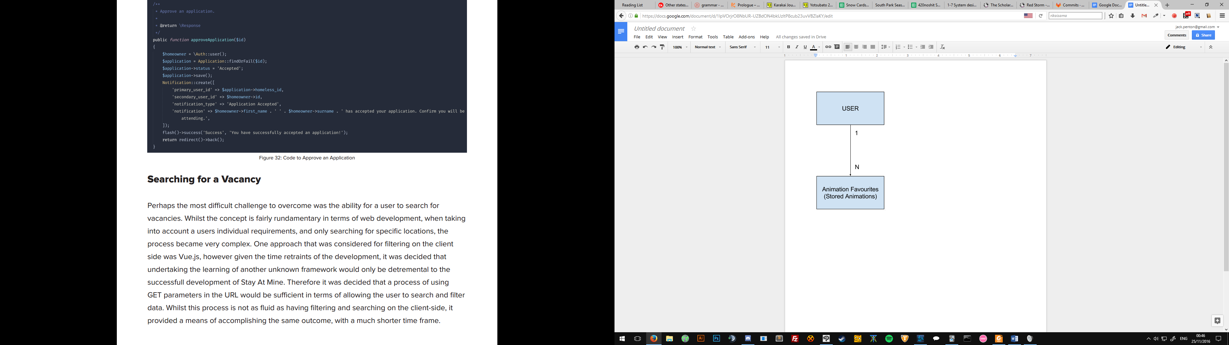ER Diagram

In terms of Database design you have to initially understand what it is that needs to be created.  
An ER Diagram to the right has been made to show the relation of “Users Saved Animations”. Whenever a user saves an animation he/she has selected or customized their animation and save it, it will be stored as one of the many animations, the user can then go to their favourite animations section and choose to download or copy that animation.

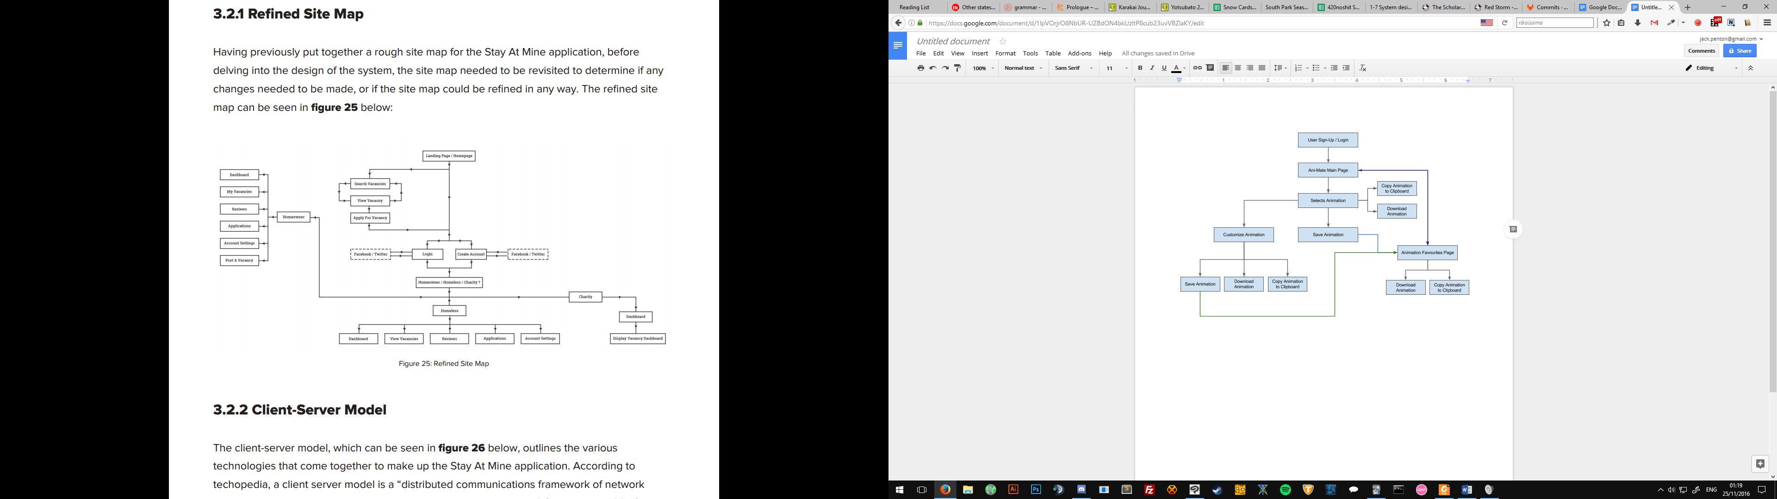User Technical Flow Diagram

The above is a diagram detailing the flow that users will make when accessing the site along with the functionailities and features that they can interact with throughout the process.

The user can Sign-Up or Login, get directed to the main Animation Page and from here they can decide to visit their current saved animations or select an animation and either begin customizing it, download it, copy it to clipboard or just save it straight off for future use.

References

Cssmatic.com. (2016). *Box Shadow CSS Generator | CSSmatic*. [Online] Available at: http://www.cssmatic.com/box-shadow [Accessed 11 Oct. 2016].

Minimamente.com. (2016). *Magic Animations CSS3*. [Online] Available at: https://www.minimamente.com/example/magic_animations [Accessed 11 Oct. 2016].

Hover.css. (2016). *Hover.css - A collection of CSS3 powered hover effects*. [Online] Available at: http://ianlunn.github.io/Hover/ [Accessed 12 Oct. 2016].

Daneden.github.io. (2016). *Animate.css*. [Online] Available at: https://daneden.github.io/animate.css/ [Accessed 13 Oct. 2016].

Blake, J. (2016). *Animation in Web Design: Why and When to Use*. [Online] Line25.com. Available at: http://line25.com/articles/animation-web-design-why-and-when-to-use [Accessed 12 Oct. 2016].

Nabors, R. and Nabors, R. (2014). *The State of Animation 2014 – Smashing Magazine*. [Online] Smashing Magazine. Available at: https://www.smashingmagazine.com/2014/11/the-state-of-animation-2014/ [Accessed 12 Oct. 2016].

Appendix

Major Project Concept Proposal 1

|  |  |
| --- | --- |
| Student name: | Jack Penton (B00662595) |
| Mentor name: | Jonathan Wallace |
| Concept title: | CSS Animation Previewer |

Concept description:

|  |
| --- |
| A website in browser that allows you to select pre-made (by me) CSS3 Animation sets and watch a live preview play out in real time, along with dispensing the code that make the animation so as the user can copy it for their own use.  The ability to also change certain specifics of the animation such as time-delay, rotation etc.… to allow more customisability for each user’s needs.  I see a lot in current websites that you can get a preview of the animation that will happen but in order to use that animation or customize it you have first got to download the source file and finally link it in your code in order to use it, whereas my idea allows you to detail your own animation from the one given and immediately take that code and pop it into your style.css |

Anticipated end product:

|  |
| --- |
| I anticipate the product will have its core features needed to have it functional. I find it difficult to correctly know how something like this will turn out in the end but I figure that it will accomplish most of what I set out to do. Allowing the user to customize specifics of the animations with sliders seems to me right now as one of the most intricate.  Overall I see this being highly beneficial for me in the long run due to the challenge and technical hurdles currently unknown. |

Resources required:

|  |
| --- |
| HTML5, CSS3, JavaScript, JQuery, Research into creating my own animations. |

IMD Major Project Concept Proposal 2

|  |  |
| --- | --- |
| Student name: | Jack Penton (B00662595) |
| Mentor name: | Jonathan Wallace |
| Concept title: | Comic Book Browser Reader |

Concept description:

|  |
| --- |
| An in-browser Comic Book reader that allows you to upload images of your comic and display them in browser with the ability to click through the pages with the option of using a selection of animations.  The option of various page layout styles also offer the user more options in terms of what they would want. |

Anticipated end product:

|  |
| --- |
| The end product should reach its full functionality, with animated page turning, page layouts.  I foresee a challenge with the database side of things where uploading, storing images and page ordering could cause some difficulty.  Overall I believe this to be a quite doable albeit the hurdles. |

Resources required:

|  |
| --- |
| HTML5, CSS3, JavaScript, JQuery, PHP, Databases |